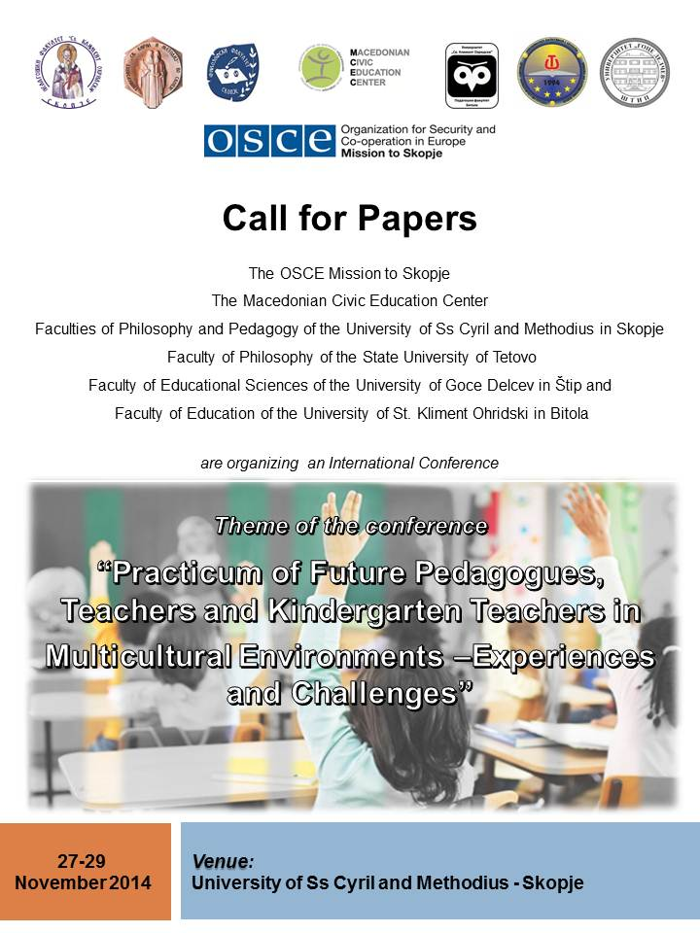

Call for Papers
The OSCE Mission to Skopje
The Macedonian Civic Education Center
The Faculties of Philosophy and Pedagogy of the University of Ss Cyril and Methodius in Skopje
The Faculty of Philosophy of the State University of Tetovo
The Faculty of Educational Sciences of the University of Goce Delcev in Štip and
The Faculty of Education of the University of St. Kliment Ohridski in Bitola
are organizing
an International Conference
to be held at the Faculty of Philosophy of the University of Ss Cyril and Methodius in Skopje,
from 27 to 29 November 2014

This Conference is dedicated to advancing the theory and practice of preparing future education professionals for work in multicultural environments. The Conference will promote collaborative excellence between academia and practitioners involved in the practical training of future teachers, and it will bring together the experiences and challenges encountered by the institutions in their efforts to provide better practicum placements for their students. This is a first-of-its-kind conference organized jointly by all five teacher training institutions in the country with the support of the Organization for Security and Co-operation in Europe (OSCE) Mission to Skopje and the Macedonian Civic Education Center (MCEC). The main theme of the conference is “Practicum of Future Pedagogues, Teachers and Kindergarten Teachers in Multicultural Environments – Experiences and Challenges”.
Important dates:
- Deadline for Submission of Abstracts: 20 August 2014

- Second deadline for submission of Abstracts: 15 September 2014
- Notification of Acceptance of Abstracts: 20 September 2014
- Deadline for Submission of Applications: 10 November 2014
- Conference: 27-29 November 2014
There is no registration fee for participation in the conference. However, all participants and presenters are required to register using the application form at the end of this document. The completed form should be sent to conference.practicum@gmail.com
The participants will cover their own accommodation and travel costs.
The abstracts will be reviewed and examined by an independent, external scientific board. The selected abstracts and papers will be reviewed and published in the CD with Conference Proceedings.
PROGRAMME AND ORGANISING COMMITTEE:
Lulzim Ademi, PhD
Assistant Professor, University of Ss Cyril and Methodius in Skopje, St Kliment Ohridski Faculty of Pedagogy
Kushtrim Ahmeti, MA
Teaching Assistant, State University of Tetovo, Faculty of Philosophy
Valentina Gulevska, PhD
Professor, University of St Kliment Ohridski in Bitola, Faculty of Education
Alma Tasevska, PhD
Assistant Professor, University of Ss Cyril and Methodius in Skopje, Faculty of Philosophy, Institute of Pedagogy
Nikola Smilkov, PhD
Professor, Goce Delcev University in Štip, Faculty of Education Sciences
Vesna Makashevska, PhD
Associate Professor, University of Ss Cyril and Methodius in Skopje, St Kliment Ohridski Faculty of Pedagogy
Nebojsa Mojsoski
Chief of Party
USAID Interethnic Integration in Education Project (IIEP)
Macedonian Civic Education Center (MCEC)
Ioana Cosma
Chief of Good Governance Unit, Organisation for Security and Cooperation in Europe, Mission to Skopje
Emilija Simonovska Janackovska, MA
National Programme Officer, Organisation for Security and Cooperation in Europe, Mission to Skopje
Jelena Brajovik, MA
Programme Assistant, Organisation for Security and Cooperation in Europe, Mission to Skopje

SCIENTIFIC BOARD:
Metodija Stojanovski, PhD
Professor at the Faculty of Education, University of St Kliment Ohridski in Bitola
Lena Damovska, PhD
Professor at the Faculty of Philosophy, University of Ss Cyril and Methodius in Skopje
Snezhana Jovanova Mitkovska, PhD
Associate Professor at the Faculty of Education Sciences, Goce Delcev University in Štip
Bujar Saiti, PhD
Professor at the Faculty of Pedagogy at the University of Ss Cyril and Methodius in Skopje
Fadbi Osmani, PhD
Dean of the Faculty of Philosophy, State University of Tetovo
Goran Ajdinski, PhD
Dean of the Faculty of Philosophy at the University of Ss Cyril and Methodius in Skopje
Vlado Timovski, PhD
Dean of the Faculty of Pedagogy, University of Ss Cyril and Methodius in Skopje

Sonja Petrovska, PhD
Acting Dean of the Faculty of Education, Goce Delcev University in Štip
Jove Dimitrija Talevski, PhD
Dean of the Faculty of Education, University of St Kliment Ohridski in Bitola
Fehari Ramadani, PhD
Vice Rector of the State University of Tetovo
Ambassador Ralf Breth
Head of the OSCE Mission to Skopje
Roland Zisi, PhD
Dean of the Faculty of Education and Social Sciences, University Eqrem Ҫabej in Gjirokastër, Albania
Sebastian Kempgen, PhD
Vice-president Teaching and Learning, University of Bamberg, Germany
Professor Honoris Causa at the University of St Kliment Ohridski in Bitola
Josip Milat, PhD
Professor Emeritus at the University of Split, Croatia
Bozhidara Kriviradeva, PhD
Professor at the Faculty of Education at Sofia University “St. Kliment Ohridski”, Bulgaria
Damir Matanović, PhD
Dean of the Faculty for Teachers Education, J. J. Strossmayer University of Osijek, Croatia
Giovanna del Gobbo, PhD
Assistant Professor at the Department of Educational Sciences and Psychology, University of Florence, Italy

GUIDELINES FOR SUBMISSION OF PAPERS:
When preparing papers, please formulate work in accordance with the following technical parameters:
- Format

  - Paper size: А4
  - Margins: 2.5cm all around
- Abstract
  - Word limit: 250
  - Language: English
  - Keywords: maximum five, written in 11pt Times New Roman.
- Organization

  - Length of the text: maximum of 8 pages, including reference pages
  - Font: 11pt Times New Roman
  - Line spacing: 1,5
  - Details: name and surname of the author should be written at the upper left corner above the title of the work, after which 2 empty lines should be left; additional information about the author (academic title, institution, e-mail etc.) are written in the form of footnotes
  - Citations: Citations should be listed according to American Psychological Association style. See http://www.apastyle.org/

REGISTRATION FORM

[please send the completed form to conference.practicum@gmail.com]
Skopje, 27 – 29 November 2014
Name and Surname
Academic Title
Institution
E-mail Address
Postal Address
Telephone Number
Title of the Paper

Abstract (up to 250 words)
Keywords (maximum 5)
Power point presentation

Yes ☐ No ☐

